Question 1)

UA:

eduroam RSSI = -57 dbm

Campus Air RSSI = -57 dbm

Radbot RSSI = -83 dbm

MaxSIMhealth_5g RSSI = -79 dbm

MaxSIMHealth RSSI = -83 dbm

Eastonia1 RSSI = -83 dbm

Science-Guest RSSI = -83 dbm

Science-DPSK RSSI = -83 dbm

Science RSSI = -79 dbm

Wilden2.4 RSSI = -83 dbm

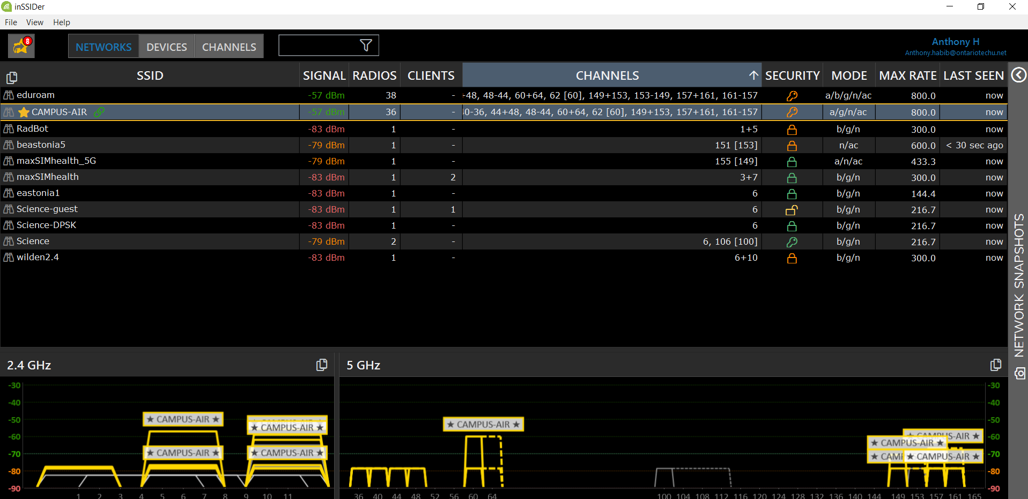

UB:

Campus Air RSSI = -48 dbm

Eduroam RSSI = -42 dbm

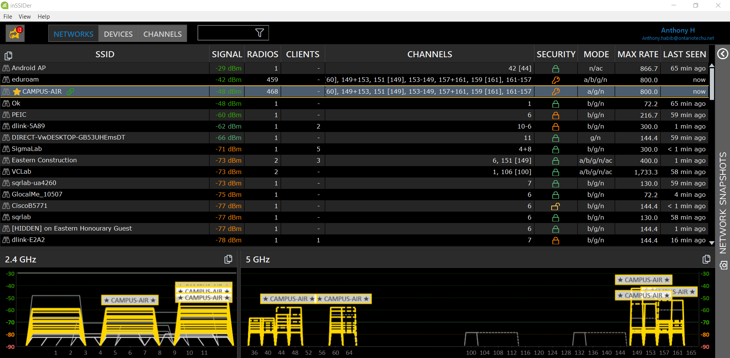

ERC:

Eduoram RSSI = -40 dbm

Campus Air RSSI = -44 dbm

Insight RSSI = -60 dbm

CiscoB5771 RSSI = -62 dbm

Dlink-5A89 RSSI = -62 dbm

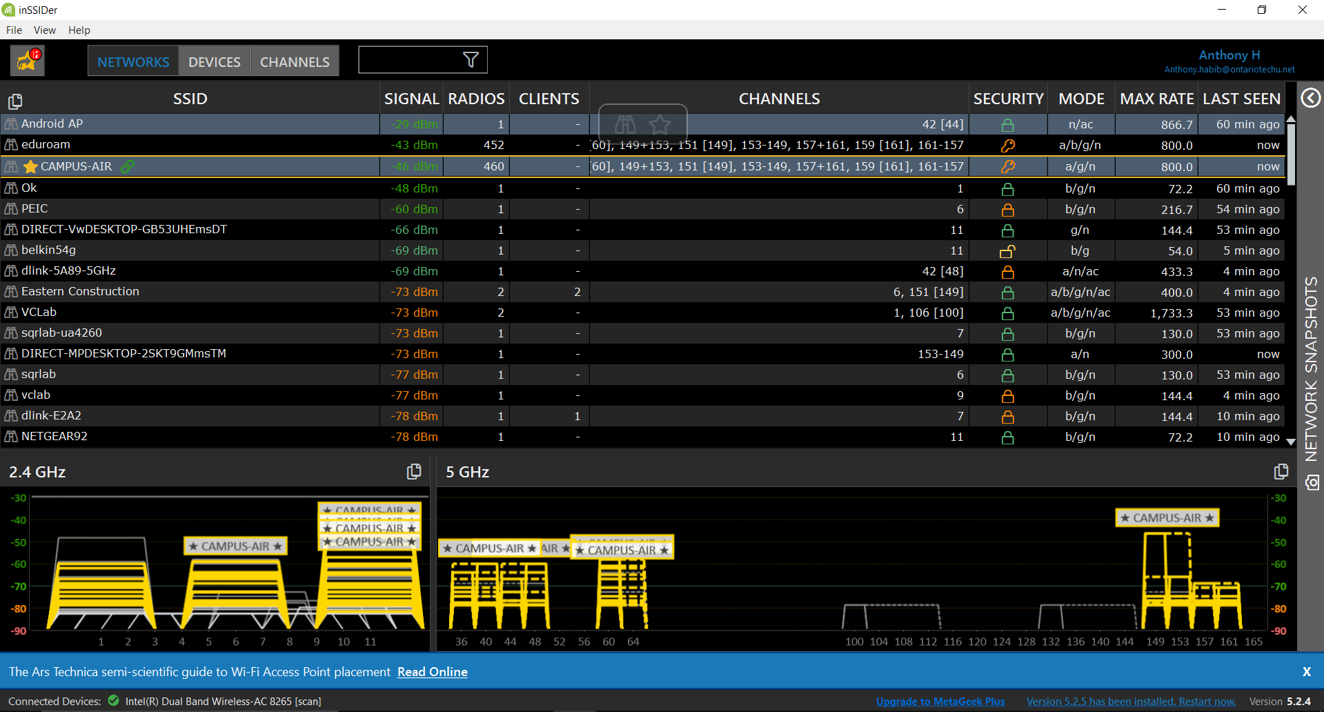

Library:

Eduroam RSSI = -43 dbm

Campus-Air RSSI = -46 dbm

Direct-MPDesktop-2skt9gmmstm RSSI = -73 dbm

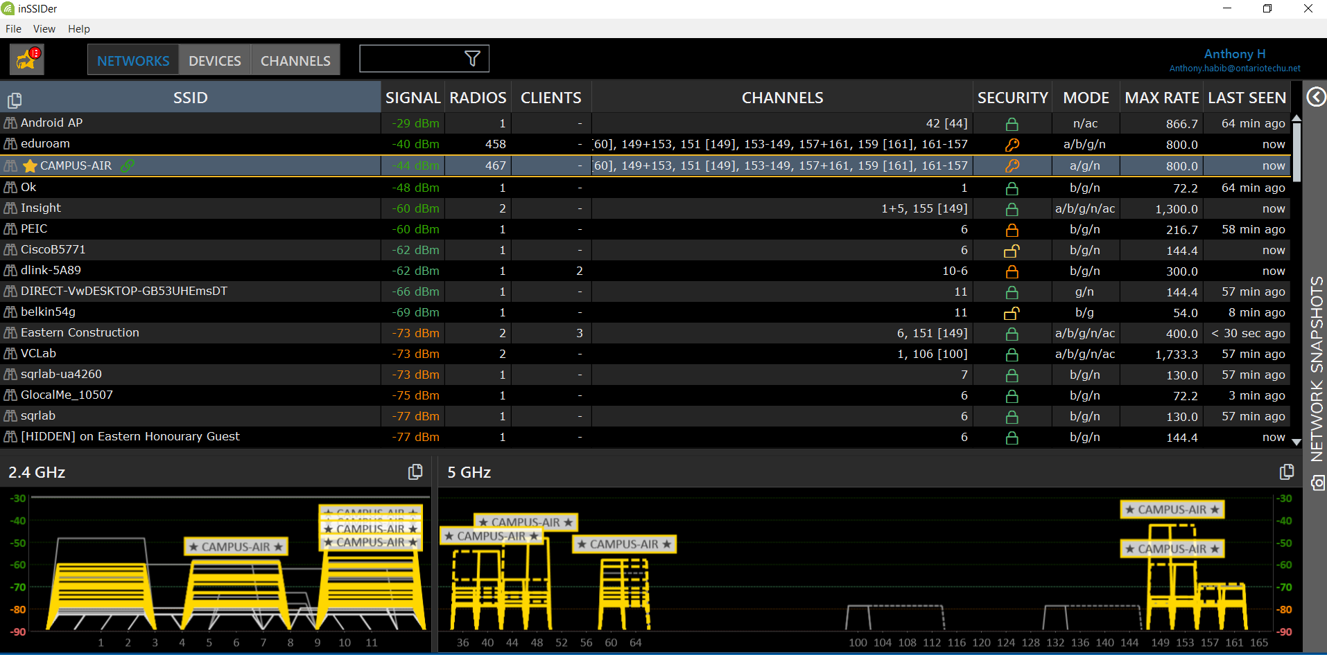

SIRC:

Eduroam RSSI = -48 dbm

Campus Air RSSI = -52 dbm

DC_Access RSSI = -70 dbm

Lab_Access RSSI = -70 dbm

[Hidden] on Lab_Access RSSI = -71 dbm

HotspotBE9E RSSI = -78 dbm

SIRC3160 RSSI = -79 dbm

SIRC3130 RSSI = -79 dbm

Wifi Hotspot 3443 RSSI -83 dbm

HP-Printer-2F-Officejet pro 8610 RSSI = -83 dbm

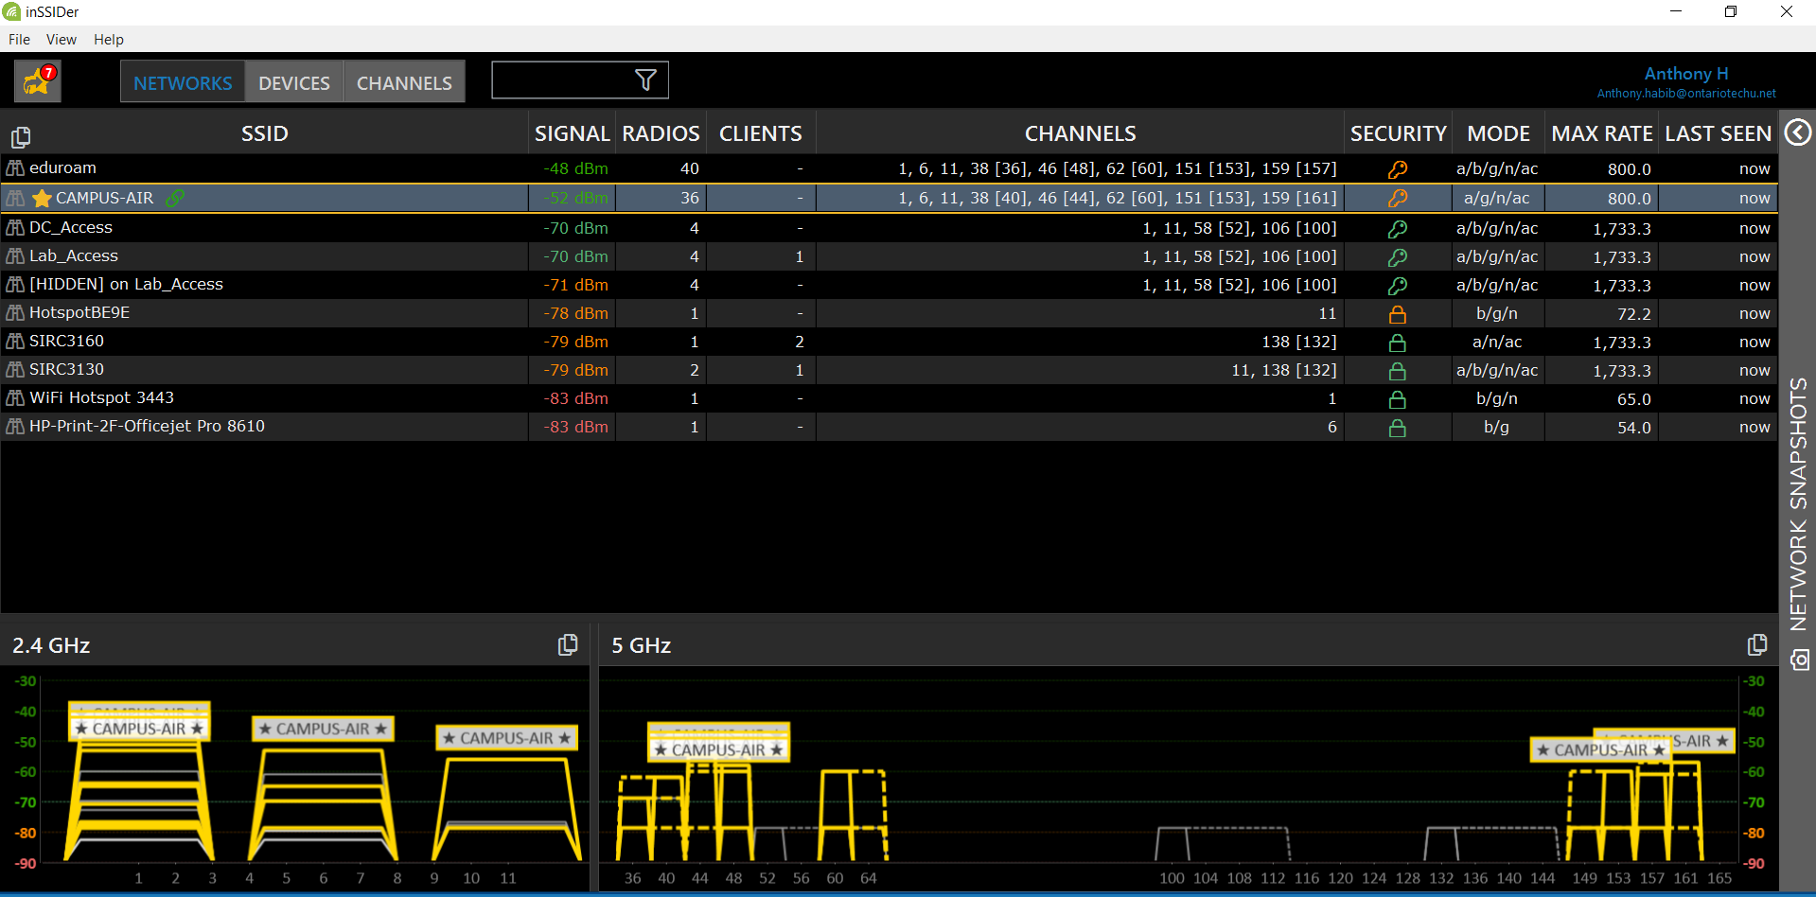

Question 2)

Heatmap of UA:

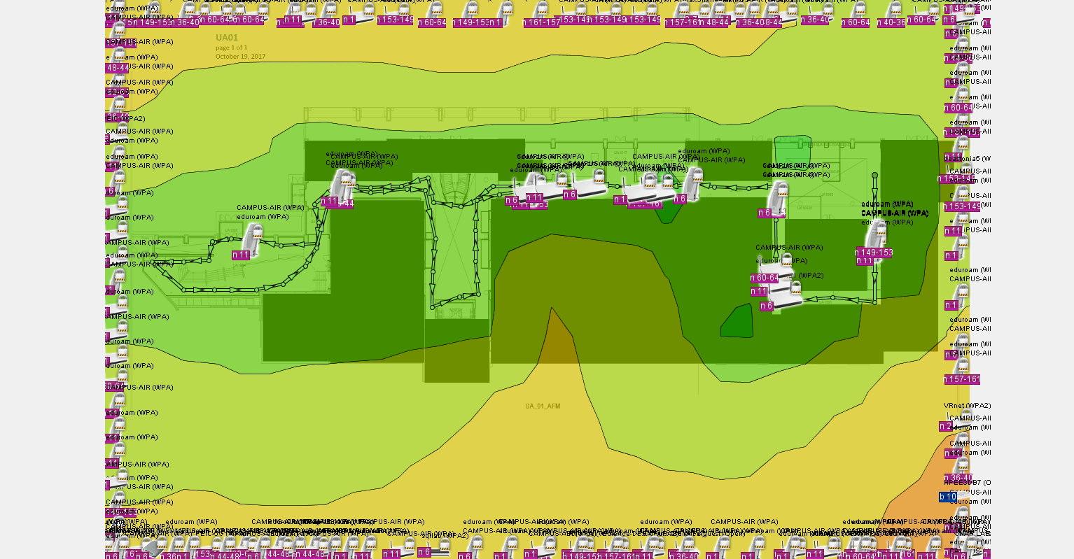

Heatmap of UB:

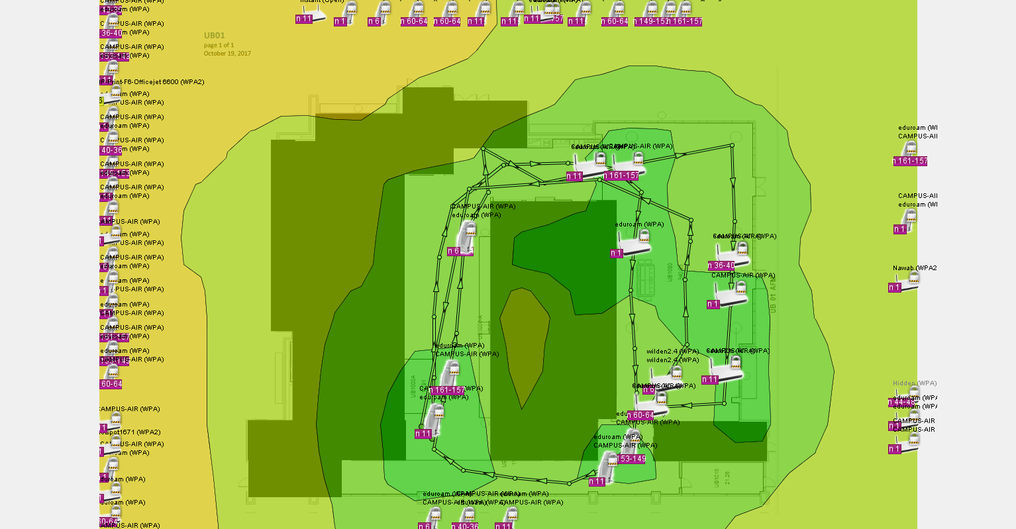

Heatmap of ERC:

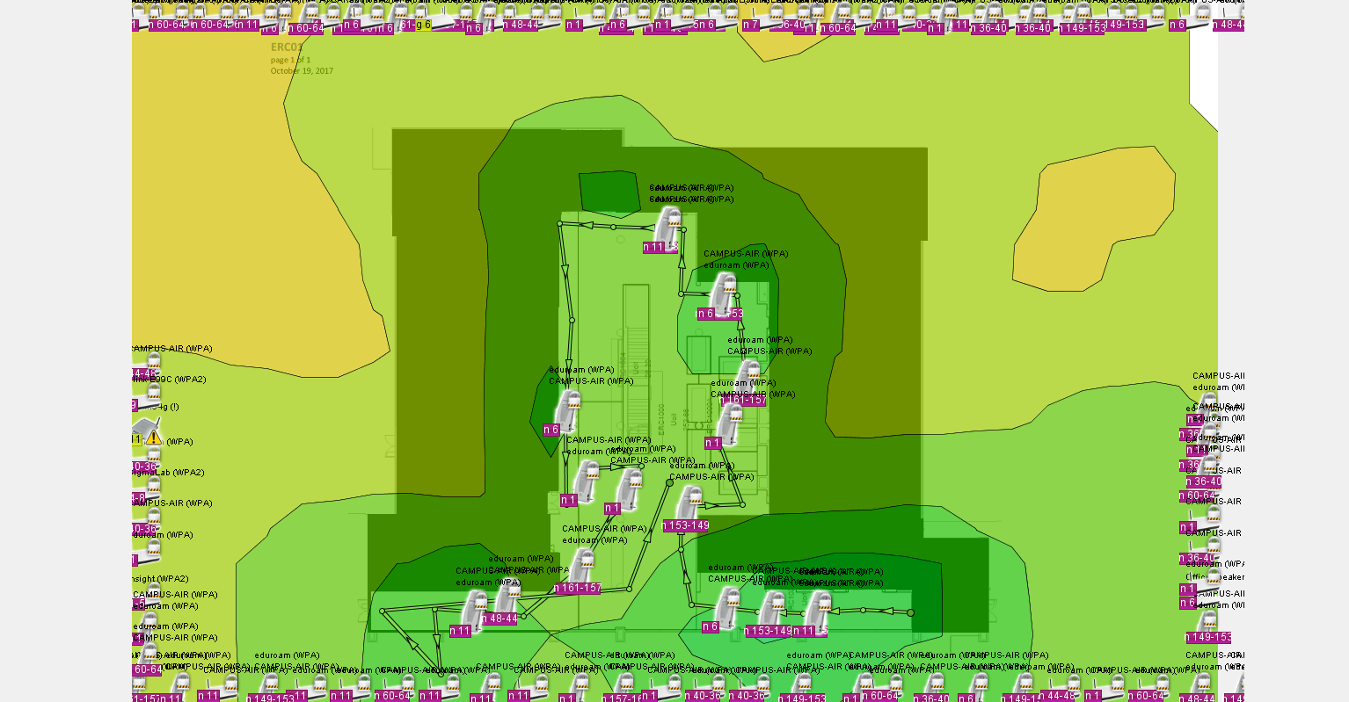

Heatmap of Library:

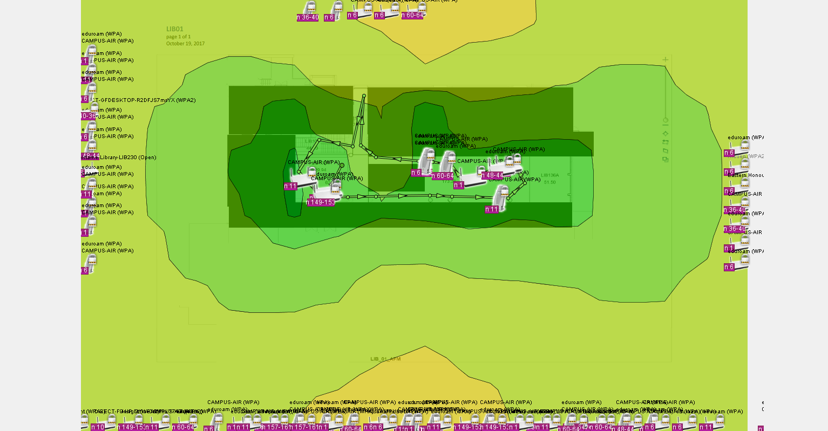

Heatmap of SIRC:

